Northwind-Homework

## Exercise 1

Write a SELECT query to display Full name of all employees in lower-case as following:  
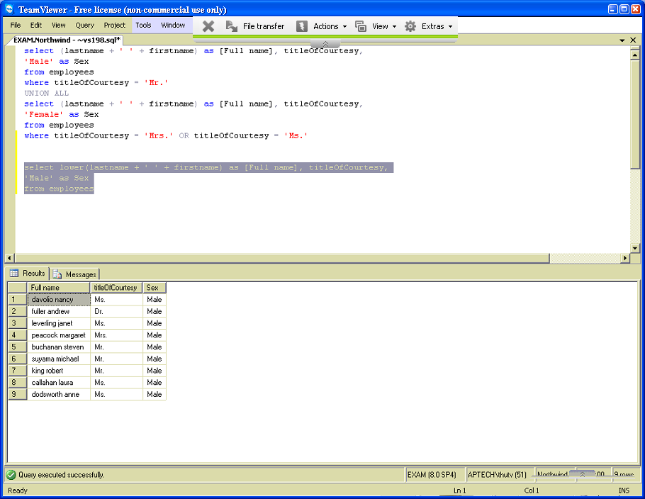

## Exercise 2

Write a SELECT query to display Full name of all employees in upper-case as following:  
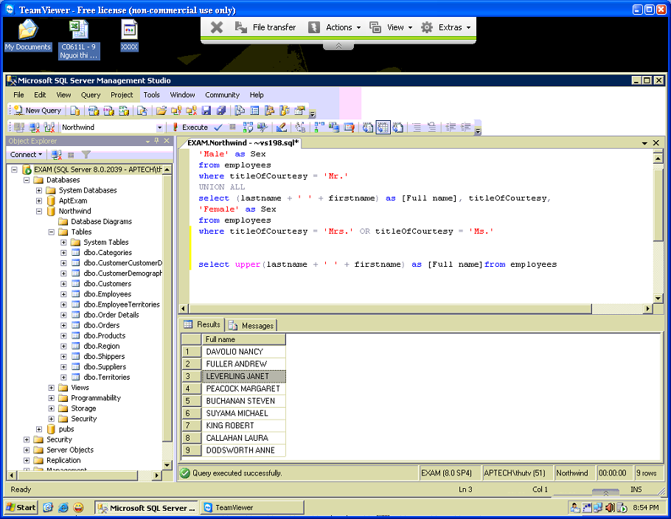

## Exercise 3

Write a SELECT query to display all employees that are from United States as following:  
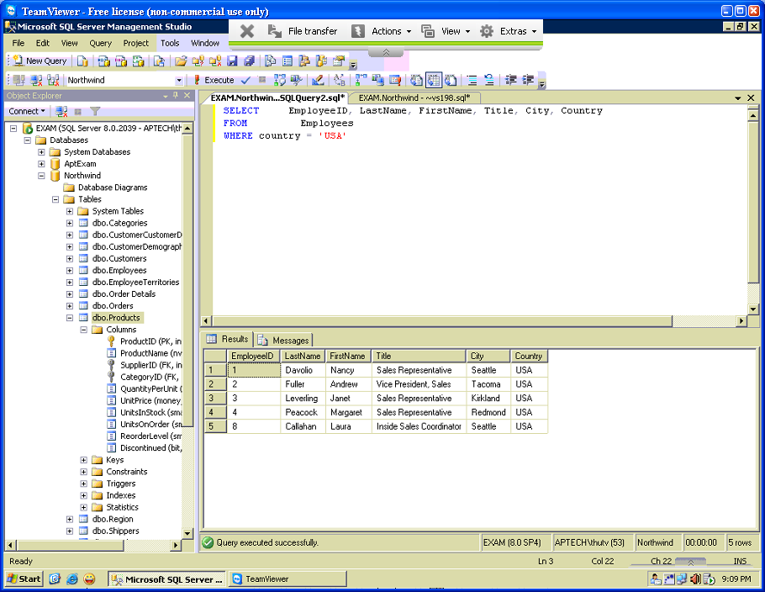

## Exercise 4

Write a SELECT query to display all customers that are from UK as following:  
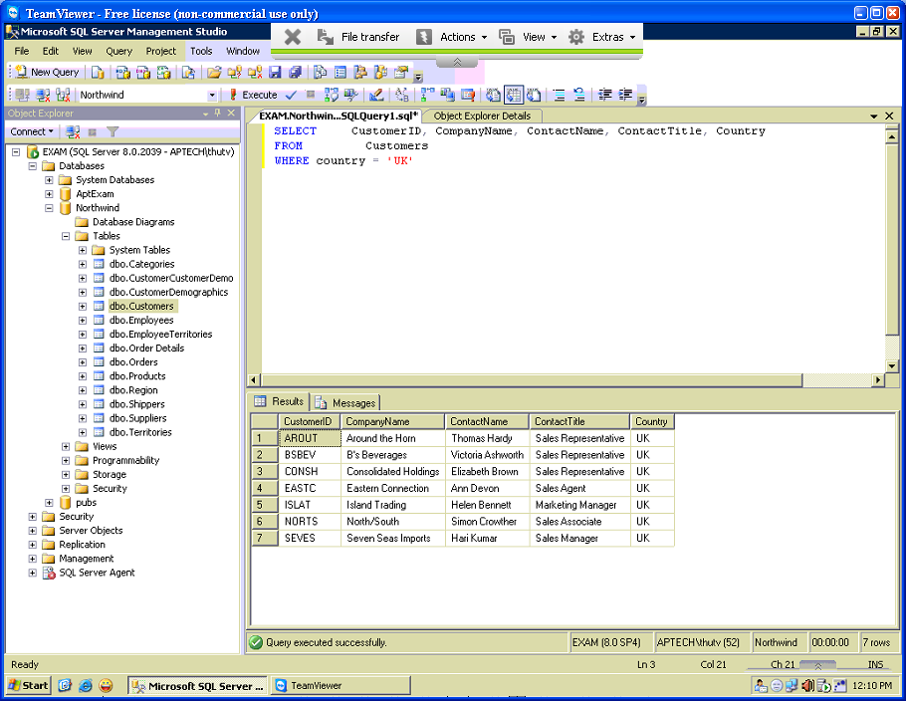

## Exercise 5

Write a SELECT query to display all customers that are from Mexico as following:  
